**Homework 6**

**Machine Learning I: Supervised Methods**

**EE 559**

Shivansh Amattya

5982564472

Solution 1 (a):

The C parameter indicates to the SVM optimizer how much misclassification of each training example should be avoided. For large values of C, the optimization will pick a smaller-margin hyperplane if it performs better at accurately classifying every training point. The optimizer will search for a larger-margin separating hyperplane even if it misclassifies more points if C is set to a relatively small value, on the other hand. Even if your training data can be linearly separated, you should frequently receive misclassified samples for minimal values of C.

**For C = 0.01**

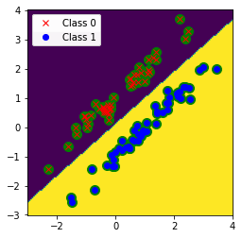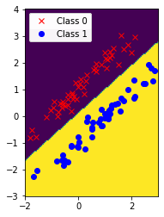

* Test Accuracy : 100.0
* Train Accuracy : 100.0
* Weight : [[ 0.47617753 -0.53480959]]
* Bais : [0.06369157]

**For C = 1**

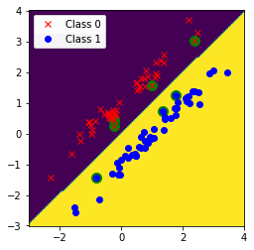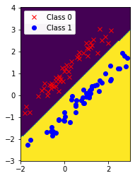

* Test Accuracy : 100.0
* Train Accuracy : 100.0
* Weight : [[ 1.52672792 -1.54421194]]
* Bias : [0.04306309]

Both C=0.01 and C=1 have the same accuracy. As a result, neither an increase nor a decrease is notable.

Solution 1(b) :

Machine learning uses a linear or nonlinear decision boundary to categorize data points into different groups. The classifier in support vector machines is set by a kernel function, and the parameter influences its complexity or smoothness. Greater Values lead to more complex choice boundaries and potentially smaller, more fragmented decision regions, whereas smaller values produce smoother decision boundaries and simpler decision regions. To avoid either overfitting or underfitting, the selection must be fine-tuned through experimentation.

**C = 0.01 and Gamma=1**

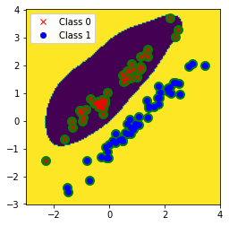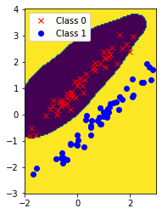

* Test Accuracy : 99.0
* Train Accuracy : 99.0

**For C = 0.01 and Gamma =3**

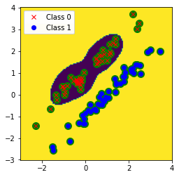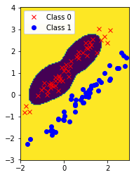

* Test Accuracy : 92.0
* Train Accuracy : 95.0

**For C = 0.01 and Gamma =10**

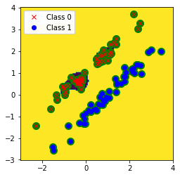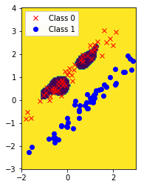

* Test Accuracy : 77.0
* Train Accuracy : 88.0
* overfitting.

**For C = 0.01 and Gamma =50**

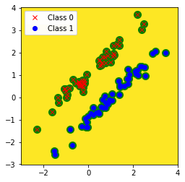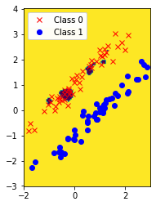

* Test Accuracy : 60.0
* Train Accuracy : 79.0
* Overfitting.

When Gamma values are low, the decision boundary is not linear because the data is not linearly separable. When Gamma values are high, we observe high accuracy. When Gamma values are low, we observe low accuracy.

Solution 1(c):

For C=1 with Linear Kernel

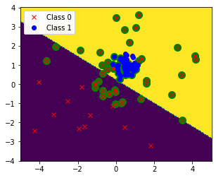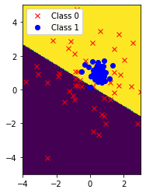

* Test Accuracy : 74.0
* Train Accuracy : 76.0
* Weight : [[0.47927439 0.78667459]]
* Bias : [-0.16998607]

For C=100 with Linear Kernel

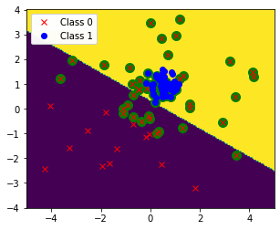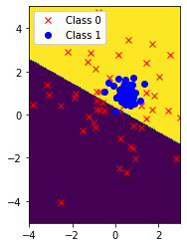

* Test Accuracy : 75.0
* Train Accuracy : 77.0
* Weight : [[0.49088855 0.86936408]]
* Bias : [-0.26411213]

As the data cannot be separated linearly, using a linear classifier is not a smart idea.

Solution 1(d):

**For C = 1 with rbf and Gamma =0.1**

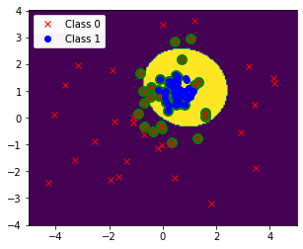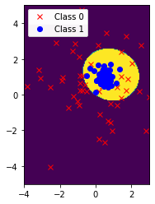

* Test Accuracy : 89.0
* Train Accuracy : 89.0

**For C = 1 with rbf and Gamma =10**

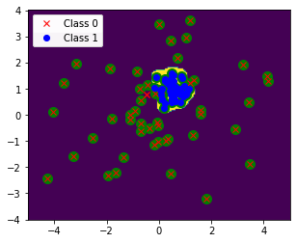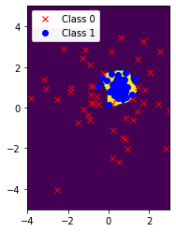

* Test Accuracy : 94.0
* Train Accuracy : 98.0

**For C = 1 with rbf and Gamma =200**

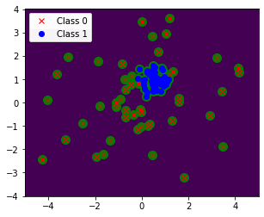

* Test Accuracy : 77.0
* Train Accuracy : 98.0

The decision boundary gets smaller as gamma rises; at high gamma levels, like gamma=200, the decision boundary disappears, and only support vectors are visible. As the test accuracy is considerably lower than the training accuracy for gamma=200, we can determine that the data is overfitted.

Solution 1(e):

When employing the Gaussian RBF kernel, the minimal test error is at Gamma = 10. The distance between the margin and the decision boundary increases as the value of C increases, while the support vector decreases, increasing the size of the decision boundary.

**For C=0.01 and Gamma = 10**

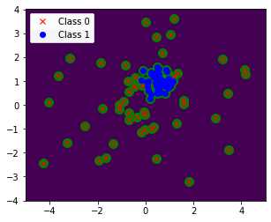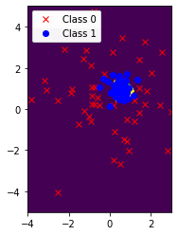

* Test Accuracy : 86.0
* Train Accuracy : 88.0
* Overlapping support vectos

**For C=1 and Gamma = 10**



* Test Accuracy : 94.0
* Train Accuracy : 98.0

**For C=100 and Gamma = 10**

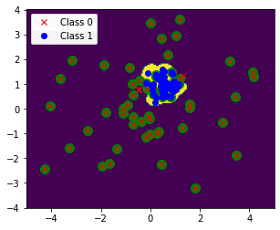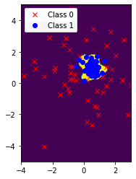

* Test Accuracy : 95.0
* Train Accuracy : 98.0
* Best accuracy compared to above

